Community Champion Communications Toolkit

Theme: Planning ahead and making your wishes known

Suggested timeframe: February, March
Instructions for toolkits can be found here. Please adapt any/some/all of the below as you wish!
Now that the new year is in full swing, it’s a perfect time to start thinking about how to make sure we are as prepared as possible when planning for our care and thinking about our health care wishes. Whether that’s emergency preparedness when something happens to change our current situation or planning ahead as an act of love and respect, let’s take these next two months to think about what preparedness means to us, and who we want to involve in that process. Picking a health care proxy/agent/surrogate and talking together is the goal for this theme.
And, National Healthcare Decisions Day (NHDD) is just around the corner on April 16th. We hope this content will help you plan ahead for NHDD and whet the appetite for ongoing conversationS (with a capital “S” as this isn't a one and done thing!).
Sample messaging to be adapted and used in newsletters, email, flyers or other mass send outs
Talk about it! Plan ahead and make your wishes known
It's never too soon to think about and talk about what's important to you, in your life and in your health, with a trusted person. So, who's your person(s)? Who would you want to support your choices or speak for you if you were unable to voice your choices? Planning ahead and talking about it with your trusted person puts you in the driver's seat. The more you speak up, before a medical crisis happens, the better your health care can be.
Whether you are getting ready to tell someone what you value most or you want to help someone else get ready to share their wishes with you, The Conversation Project has you covered with free resources on their Get Started page. Check out their guides on Choosing a Health Care Proxy or Being a Health Care Proxy, among many others. You can speak up and have a say in your current or future health care by being prepared and talking about it early and often.

Sample text/images to be adapted as you wish: for Social Media or Use in Newsletters, Flyers, Emails, etc.(instructions for use here, including downloading images)

The following examples are tailored to three social media platforms (Instagram, Facebook, X/Twitter) but can be used/adapted more broadly in other social media platforms and/or other communications methods you use.
Instagram:
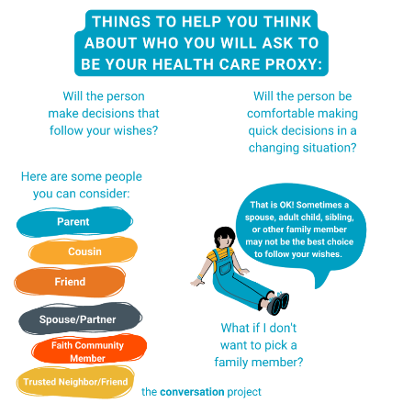
Option #1
Who's your person? Who do you trust to speak on your behalf if you are unable to make decisions about health care choices? Need a little help to decide? @convoproject is here to help with free guidance. We can’t plan for everything. But we can talk about what is most important — in our life, and in our health care — with those who matter most.
🔗 Go visit the link in our bio/visit the linktree in our bio to read through @convoproject’s free guide: Your Guide to Choosing a Health Care Proxy.
Link to add to your bio/linktree: https://theconversationproject.org/wp-content/uploads/2020/12/ChooseAProxyGuide.pdf
Additional hashtags to copy and paste into your first Instagram comment:
#TCP #TheConversationProject #PlanningAhead #FreeGuides #HealthCareProxy #Beingaproxy #cancercare #talkingaboutcancer #chf #parkinsons #alzheimers #dementia #als #COPD #cysticfibrosis #palliative #palliativecare #conversation #caregiver #caregiving #SeriousIllness #healthcareagent #surrogate #healthcaresurrogate #powerofattorney #estateplanning #patientsafety #elderlaw
Option #2
If you’re racking your brain trying to figure out how to initiate meaningful conversations with the people who matter most in your life, these simple ice breakers may be just the thing you’re looking for to get those conversations started. Look through these ideas and choose the ones that you feel would best fit your unique situation. We know this is not a one-size-fits-all approach, which is why we want to give you as much variety as possible to choose from.
🔗 Go visit the link in our bio/visit the linktree in our bio to access @convoproject’s blog: Thoughtful Ice Breakers That Lead to Meaningful Conversations.

NOTE: This asset is meant to be posted as a carousel or uploaded as multiple images in one. You may choose to only post some of the options in the carousel.
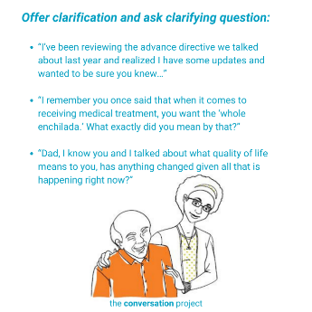
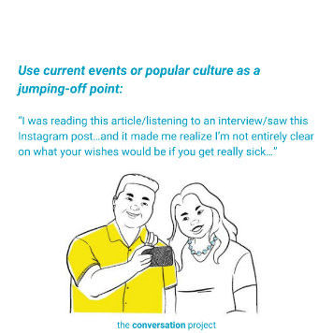
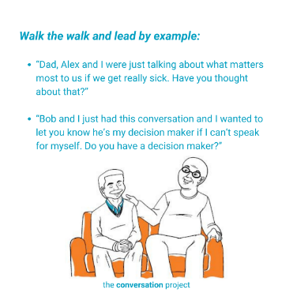
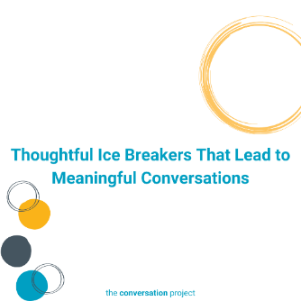

Link to add to your bio/linktree: https://theconversationproject.org/tcp-blog/thoughtful-ice-breakers-that-lead-to-meaningful-conversations/
Additional hashtags to copy and paste into your first Instagram comment:
#TheConversationProject #TCP #PlanningAhead #FreeGuides #HealthCareProxy #ChooseYourProxy #IceBreakers #MeaningfulConversations #MeaningfulConversations #ConversationStarterGuide #dinnertabletalk #betterconversations #betterquestions #qualityconversation #conversation #caregiver #caregiving #SeriousIllness #WhatMattersToMe #WhatMattersMost #healthcareagent #surrogate #healthcaresurrogate #powerofattorney
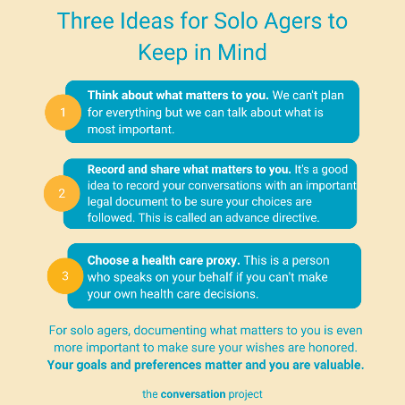
Option #3
Planning for your future is important for everyone. For solo agers, documenting what matters to you is even more important to make sure your wishes are understood and honored.
🔗 Go visit the link in our bio/visit the linktree in our bio to read a few suggestions from @convoproject in their blog, Three Ideas for Solo Agers to Keep in Mind.
Link to add to your bio/linktree: https://theconversationproject.org/tcp-blog/three-ideas-for-solo-agers-to-keep-in-mind/
Additional hashtags to copy and paste into your first Instagram comment:
#TCP #TheConversationProject #Conversation #PlanningAhead #Caregiver #Caregiving #SeriousIllness #WhatMatterstoMe #WhatMattersMost #ConversationGuide #StartingTheConversation #SoloAgers #AdvanceDirective #HealthCareProxy #Aging #Retirement #ActiveAdult #AgeinPeace #EstatePlanning #LivingWill #ElderLaw
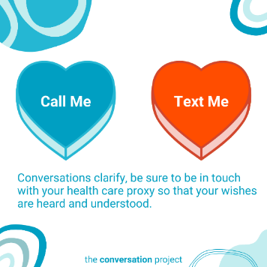
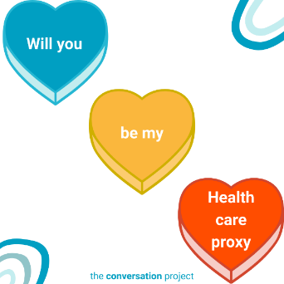
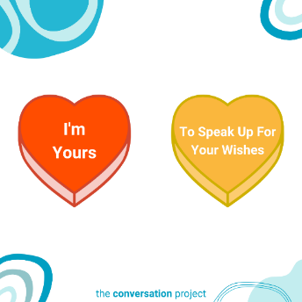
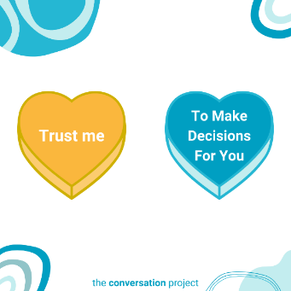
Option #4
This Valentine’s Day, remember that planning ahead is an act of love. Think of those in your life who you may want to share your own health care wishes with and think about how you might want to start those conversations with them about your care.
🔗 Go visit the link in our bio/visit the linktree in our bio to read through @convoproject’s materials on how to be a health care proxy or how to choose a health care proxy for suggestions on who to talk with and how to start these conversations.
- OR -
This Galentine’s Day, make sure all your friends are accounted for and taken care of. Shoot them a message! Be sure to check in on those you care about the most and let them know you’re here to listen.
🔗 Go visit the link in our bio/visit the linktree in our bio to read through @convoproject’s materials on how to be a health care proxy or how to choose a health care proxy for suggestions on who to talk with and how to start these conversations.
Link to add to your bio/linktree:
https://theconversationproject.org/wp-content/uploads/2020/12/ChooseAProxyGuide.pdf
OR
https://theconversationproject.org/wp-content/uploads/2020/12/BeAProxyGuide.pdf
Additional hashtags to copy and paste into your first Instagram comment:
#TCP #TheConversationProject #conversation #caregiver #caregiving #SeriousIllness #PlanningAhead #WhatMattersToMe #WhatMattersMost #ConversationStarters #ValentinesDay #HeartCandy #ConversationHearts #TrustMe #WillYouBeMyValentine #healthcareproxy #chooseaproxy #CandyHearts #Valentines
Facebook:
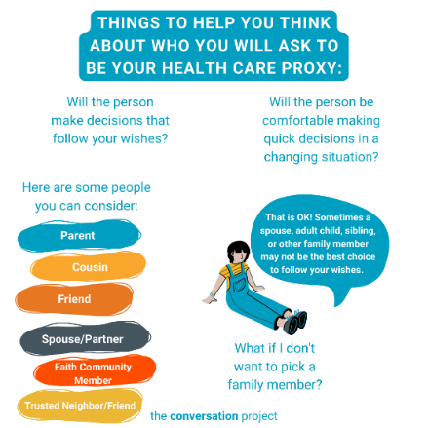
Option #1
Who's your person? Who do you trust to speak on your behalf if you are unable to make decisions about health care choices? Need a little help to decide? @TheConversationProject is here to help with free guidance. We can’t plan for everything. But we can talk about what is most important — in our life, and in our health care — with those who matter most. #PlanningAhead
Follow the link below to check out @TheConversationProject’s free guide: Your Guide to Choosing a Health Care Proxy.
https://theconversationproject.org/wp-content/uploads/2020/12/ChooseAProxyGuide.pdf

Option #2
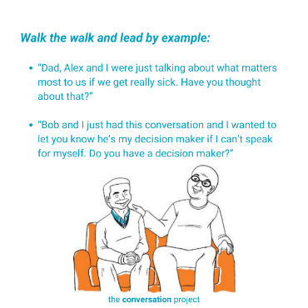
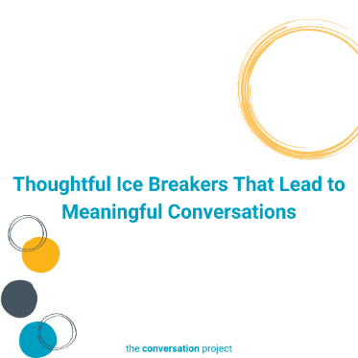
If you’re racking your brain trying to figure out how to initiate meaningful conversations with the people who matter most in your life, these simple ice breakers may be just the thing you’re looking for to get those conversations started. Look through these ideas and choose the ones that you feel would best fit your unique situation. We know this is not a one-size-fits-all approach, which is why we want to give you as much variety as possible to choose from. #PlanningAhead
Read @TheConversationProject’s blog: Thoughtful Ice Breakers That Lead to Meaningful Conversations.
https://theconversationproject.org/tcp-blog/thoughtful-ice-breakers-that-lead-to-meaningful-conversations/
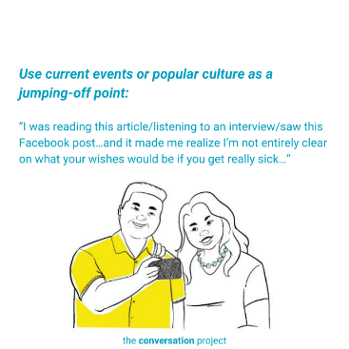
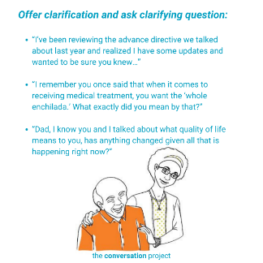

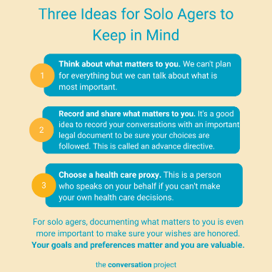
Option #3
Planning for your future is important for everyone. For solo agers, documenting what matters to you is even more important to make sure your wishes are understood and honored.
@TheConversationProject has a few suggestions in their blog, Three Ideas for Solo Agers to Keep in Mind. #PlanningAhead
https://theconversationproject.org/tcp-blog/three-ideas-for-solo-agers-to-keep-in-mind/

Option #4
Ever wish you could rewind a conversation?
Check out these three videos from @convoproject on starting meaningful conversations early and often #PlanningAhead:
https://youtu.be/cffotkDxsbU
https://youtu.be/0c0sxzW0gSU
https://youtu.be/0c0sxzW0gSU
Option #5
This Valentine’s Day, remember that planning ahead is an act of love. Think of those in your life who you may want to share your own health care wishes with and think about how you might want to start those conversations with them about your care.
Read through @TheConversationProject’s materials on how to be a health care proxy or how to choose a health care proxy for suggestions on who to talk with and how to start these conversations.
https://theconversationproject.org/wp-content/uploads/2020/12/ChooseAProxyGuide.pdf
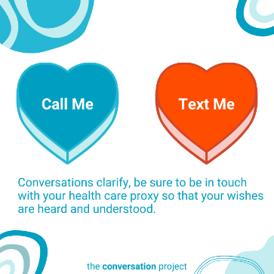
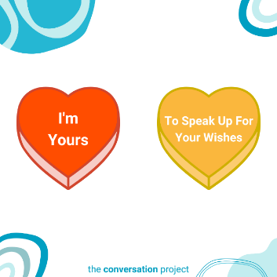
https://theconversationproject.org/wp-content/uploads/2020/12/BeAProxyGuide.pdf
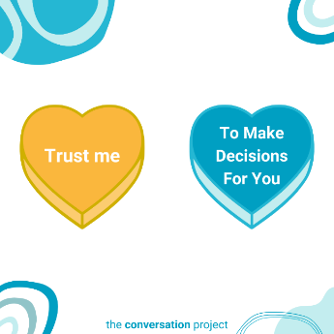
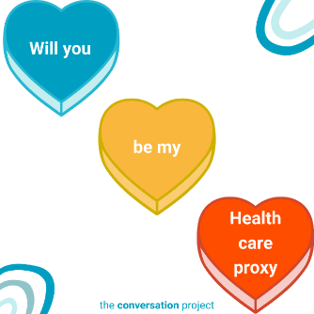
- OR –
This Galentine’s Day, make sure all your friends are accounted for and taken care of. Shoot them a message! Be sure to check in on those you care about the most and let them know you’re here to listen.
Read through @TheConversationProject’s materials on how to be a health care proxy or how to choose a health care proxy for suggestions on who to talk with and how to start these conversations.
https://theconversationproject.org/wp-content/uploads/2020/12/ChooseAProxyGuide.pdf
https://theconversationproject.org/wp-content/uploads/2020/12/BeAProxyGuide.pdf

X/Twitter:
Additional hashtags (to consider based on post/character space):
#PlanningAhead #TalkingTogether #PickingaProxy #EmergencyPreparedness
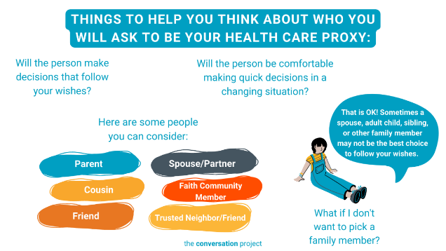
Option #1
Who's your person? Who do you trust to speak on your behalf if you are unable to make decisions about health care choices? Need a little help to decide? @convoproject is here to help with free guidance.
https://theconversationproject.org/wp-content/uploads/2020/12/ChooseAProxyGuide.pdf

Option #2
If you’re racking your brain trying to figure out how to initiate meaningful conversations with the people who matter most in your life, these simple ice breakers may be just the thing you’re looking for to get those conversations started.
https://theconversationproject.org/tcp-blog/thoughtful-ice-breakers-that-lead-to-meaningful-conversations/
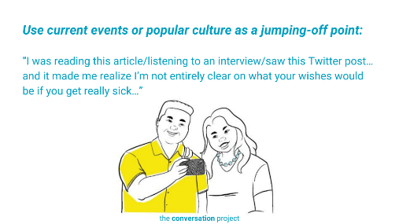
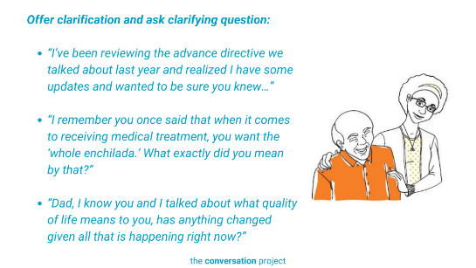
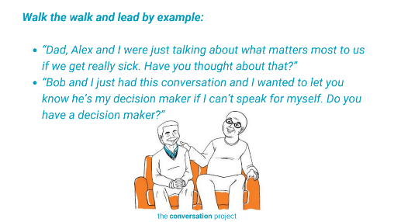

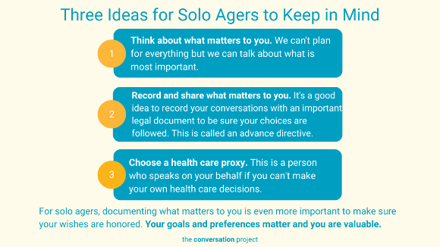
Option #3
Planning for your future is important for everyone. For solo agers, documenting what matters to you is even more important to make sure your wishes are honored.
@convoproject has a few suggestions for getting started in their blog, Three Ideas for Solo Agers to Keep in Mind. #PlanningAhead https://theconversationproject.org/tcp-blog/three-ideas-for-solo-agers-to-keep-in-mind/
Option #4
Ever wish you could rewind a conversation?
Check out these three videos from @convoproject on starting meaningful conversations early and often #PlanningAhead – these three videos showcase a few different examples of how these conversations could go with those who matter most in your life. Look through them to get some ideas:
You Guys Know PSA: https://youtu.be/cffotkDxsbU
Party on the Beach PSA: https://youtu.be/0c0sxzW0gSU
Save the Day PSA: https://youtu.be/0c0sxzW0gSU

Option #5
This Valentine’s Day, think of those in your life who you may want to share your own health care wishes with.
Read through @TheConversationProject’s materials on how to be a health care proxy or how to choose a health care proxy here:
Choose one of the below links:
https://theconversationproject.org/wp-content/uploads/2020/12/ChooseAProxyGuide.pdf
https://theconversationproject.org/wp-content/uploads/2020/12/BeAProxyGuide.pdf
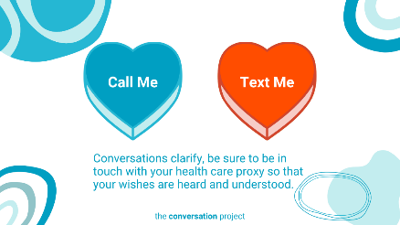
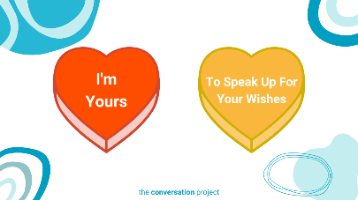
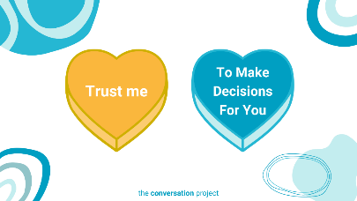
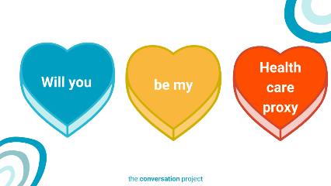
- OR -
This Galentine’s Day, make sure all your friends are accounted for and taken care of.
Read through @TheConversationProject’s materials on how to be a health care proxy or how to choose a health care proxy here:
Choose one of the below links:
https://theconversationproject.org/wp-content/uploads/2020/12/ChooseAProxyGuide.pdf
https://theconversationproject.org/wp-content/uploads/2020/12/BeAProxyGuide.pdf

Other messages/images to use across social media from the Serious Illness Messaging Toolkit*:

Talk to the people who matter most about the care you want.
The more you speak up, the better your health care can be.


Tell your doctors what matters most to you.
You can get the care that’s right for you.

*A toolkit created in partnership during a three-year grant generously funded by The John A. Hartford Foundation and Cambia Health Foundation. For more free messages, images and text, click this link and download the toolkit.
Be sure to tag, follow, and reshare content from The Conversation Project’s Instagram, Facebook, and X/Twitter accounts if you are looking for more content outside of this toolkit to support the theme: “Planning Ahead”. We’ll be posting this and more, all of which you are welcome to adapt to your own usage.
 |  | 
@convoproject | @TheConversationProject | @convoproject

What do you think of this Toolkit? Please help us and take 2 minutes to answer 3 questions in our brief survey here.

